<!DOCTYPE html>

<html>

<head>

<title>Student Registration</title>

</head>

<body>

<h1>Student Registration</h1>

<form action="register.php" method="post">

<label for="name">Name:</label>

<input type="text" name="name" required><br><br>

<label for="email">Email:</label>

<input type="email" name="email" required><br><br>

<label for="course">Course:</label>

<input type="text" name="course" required><br><br>

<input type="submit" value="Register">

</form>

</body>

</html>

<?php

// Database connection settings

$host = "localhost";

$username = "root";

$password = "";

$database = "studentdb";

// Create a database connection

$conn = new mysqli($host, $username, $password, $database);

// Check connection

if ($conn->connect_error) {

die("Connection failed: " . $conn->connect_error);

}

// Process the form data

if ($_SERVER["REQUEST_METHOD"] == "POST") {

$name = $_POST["name"];

$email = $_POST["email"];

$course = $_POST["course"];

// Insert data into the database

$sql = "INSERT INTO students (name, email, course) VALUES ('$name', '$email', '$course')";

if ($conn->query($sql) === TRUE) {

echo "Registration successful!";

} else {

echo "Error: " . $sql . "<br>" . $conn->error;

}

}

// Close the database connection

$conn->close();

?>

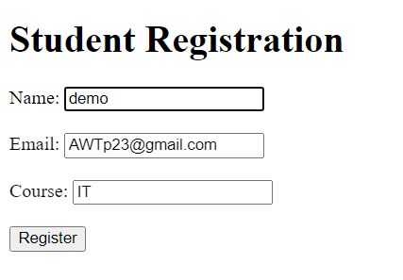

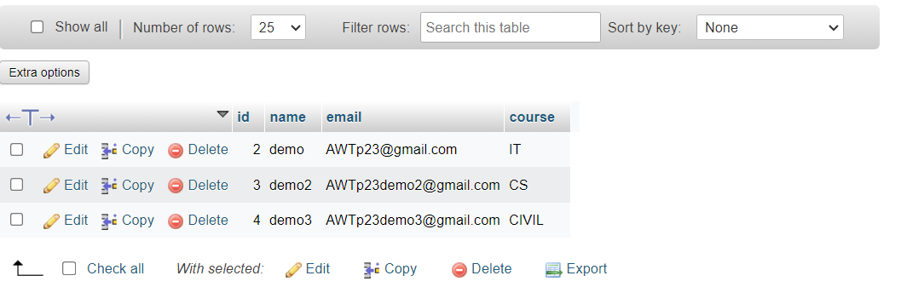

<!DOCTYPE html>

<html>

<head>

<title>Student Records</title>

</head>

<body>

<h1>Student Records</h1>

<?php

// Database connection settings

$host = "localhost";

$username = "root";

$password = "";

$database = "studentdb";

// Create a database connection

$conn = new mysqli($host, $username, $password, $database);

// Check connection

if ($conn->connect_error) {

die("Connection failed: " . $conn->connect_error);

}

// Fetch records from the database

$sql = "SELECT * FROM students";

$result = $conn->query($sql);

if ($result->num_rows > 0) {

echo "<table border='1'>

<tr>

<th>ID</th>

<th>Name</th>

<th>Email</th>

<th>Course</th>

</tr>";

while ($row = $result->fetch_assoc()) {

echo "<tr>

<td>" . $row["id"] . "</td>

<td>" . $row["name"] . "</td>

<td>" . $row["email"] . "</td>

<td>" . $row["course"] . "</td>

</tr>";

}

echo "</table>";

} else {

echo "No records found";

}

// Close the database connection

$conn->close();

?>

</body>

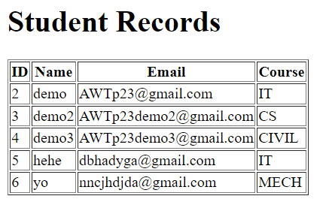</html>